**HAL. Static indication**

Today we will try to connect a seven-segment LED indicator to the STM32 controller using the HAL library. We have already connected such an indicator to the AVR microcontroller, it's time to try and do this with the STM controller. I think we will have no difficulties in this.

**Seven-segment LED indicator** is the purchase of LED segments located in a certain order

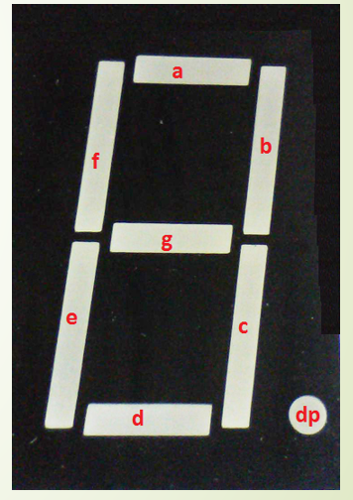

As we see, the indicator is not seven-segmented at all, but eight. Segments are usually denoted by Latin letters in alphabetical order, and the point - by the symbols dp.

We will connect our indicator here in this way (click the button to enlarge the image)

[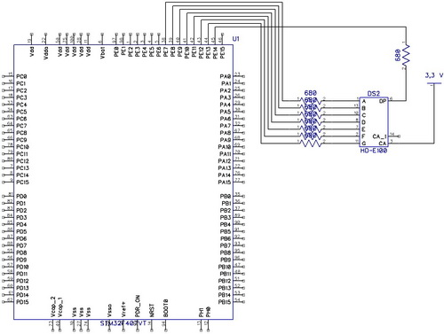](http://narodstream.ru/wp-content/uploads/2016/12/Image03-1.jpg)

Do not forget to also use resistors to provide current limiting through the legs of the ports. Since I have an indicator with a common anode, the common wire was connected to the 3.3-volt power leg.

And here's how it looks almost

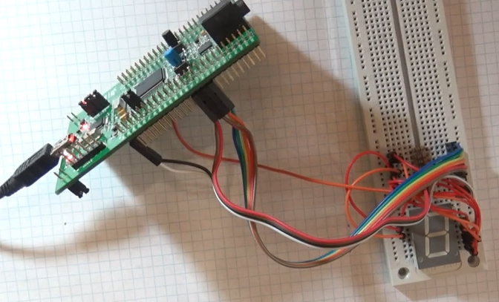

The purpose of the legs on my indicator, that is, on the one that I connected the following

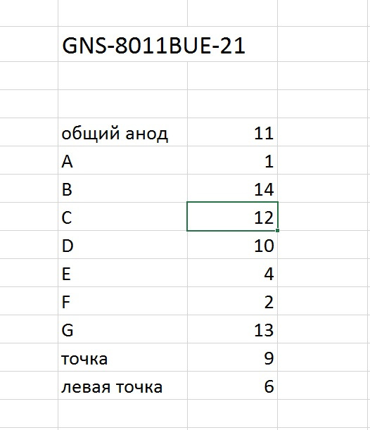

As before, the project is created from the very first (TEST001), call it LED_STAT

Start the cube, turn off all ports, turn on the output ports PE7-PE15.

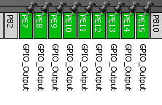

In the settings in Configuration do not touch anything at all.

We generate the project.

Create and add files main.h, led.h, led.c

In main.h and led.c we connect

#include "led.h"

in main.c

#include "main.h"

in led.h

#include "stm32f4xx_hal.h"

#include "main.h"

In the file led.h write defines (or macros) for the segments, so that it would be more convenient to work with them in the code

#define SA GPIO_PIN_7

#define SB GPIO_PIN_8

#define SC GPIO_PIN_9

#define SD GPIO_PIN_10

#define SE GPIO_PIN_11

#define SF GPIO_PIN_12

#define SG GPIO_PIN_13

#define SH GPIO_PIN_14

#define SA_SET HAL_GPIO_WritePin (GPIOE, SA, GPIO_PIN_RESET)

#define SA_RESET HAL_GPIO_WritePin (GPIOE, SA, GPIO_PIN_SET)

#define SB_SET HAL_GPIO_WritePin (GPIOE, SB, GPIO_PIN_RESET)

#define SB_RESET HAL_GPIO_WritePin (GPIOE, SB, GPIO_PIN_SET)

#define SC_SET HAL_GPIO_WritePin (GPIOE, SC, GPIO_PIN_RESET)

#define SC_RESET HAL_GPIO_WritePin (GPIOE, SC, GPIO_PIN_SET)

#define SD_SET HAL_GPIO_WritePin (GPIOE, SD, GPIO_PIN_RESET)

#define SD_RESET HAL_GPIO_WritePin (GPIOE, SD, GPIO_PIN_SET)

#define SE_SET HAL_GPIO_WritePin (GPIOE, SE, GPIO_PIN_RESET)

#define SE_RESET HAL_GPIO_WritePin (GPIOE, SE, GPIO_PIN_SET)

#define SF_SET HAL_GPIO_WritePin (GPIOE, SF, GPIO_PIN_RESET)

#define SF_RESET HAL_GPIO_WritePin (GPIOE, SF, GPIO_PIN_SET)

#define SG_SET HAL_GPIO_WritePin (GPIOE, SG, GPIO_PIN_RESET)

#define SG_RESET HAL_GPIO_WritePin (GPIOE, SG, GPIO_PIN_SET)

#define SH_SET HAL_GPIO_WritePin (GPIOE, SH, GPIO_PIN_RESET)

#define SH_RESET HAL_GPIO_WritePin (GPIOE, SH, GPIO_PIN_SET)

In the led.c we write a function for outputting the digits to the indicator.

The code for each leg is written with the condition that the segment will light up if there is a low level on this leg, and if it is high, it will not be

void segchar (uint8_t seg)

{

        switch (seg)

        {

                case 1:

                        SA_RESET; SB_SET; SC_SET; SD_RESET; SE_RESET; SF_RESET; SG_RESET; SH_RESET;

                        break;

                case 2:

                        SA_SET; SB_SET; SC_RESET; SD_SET; SE_SET; SF_RESET; SG_SET; SH_RESET;

                        break;

                case 3:

                        SA_SET; SB_SET; SC_SET; SD_SET; SE_RESET; SF_RESET; SG_SET; SH_RESET;

                        break;

                case 4:

                        SA_RESET; SB_SET; SC_SET; SD_RESET; SE_RESET; SF_SET; SG_SET; SH_RESET;

                        break;

                case 5:

                        SA_SET; SB_RESET; SC_SET; SD_SET; SE_RESET; SF_SET; SG_SET; SH_RESET;

                        break;

                case 6:

                        SA_SET; SB_RESET; SC_SET; SD_SET; SE_SET; SF_SET; SG_SET; SH_RESET;

                        break;

                case 7:

                        SA_SET; SB_SET; SC_SET; SD_RESET; SE_RESET; SF_RESET; SG_RESET; SH_RESET;

                        break;

                case 8:

                        SA_SET; SB_SET; SC_SET; SD_SET; SE_SET; SF_SET; SG_SET; SH_RESET;

                        break;

                case 9:

                        SA_SET; SB_SET; SC_SET; SD_SET; SE_RESET; SF_SET; SG_SET; SH_RESET;

                        break;

                case 0:

                        SA_SET; SB_SET; SC_SET; SD_SET; SE_SET; SF_SET; SG_RESET; SH_RESET;

                        break;

        }

}

We write a prototype for it in led.h

void segchar (uint8_t seg);

In the main module main.c in the main () function we add the code so that at the start the indicator does not shine

MX_GPIO_Init ();

  / * USER CODE BEGIN 2 * /

**HAL_GPIO_WritePin (GPIOE, GPIO_PIN_7 | GPIO_PIN_8 | GPIO_PIN_9 | GPIO_PIN_10**

**| GPIO_PIN_11 | GPIO_PIN_12 | GPIO_PIN_13 | GPIO_PIN_14,**

**GPIO_PIN_SET);**

        / * USER CODE END 2 * /

Also in main () we add a variable for the account

int main (void)

{

  / * USER CODE BEGIN 1 * /

**uint8_t i = 0;**

  / * USER CODE END 1 * /

Also adding code for an account in an infinite loop

  while (1)

  {

**for (i = 0; i <10; i ++)**

**{**

**segchar (i);**

**HAL_Delay (1000);**

**}**

        / * USER CODE END WHILE * /

We will collect the code, we'll sew the controller and see the result (in the video version of course it looks much more dynamic)

